**Дата: 19.05.2025 Предмет: англійська мова Вчитель: Таран Н.В.**

**Клас: 4-А, 4-Б**

**Тема: Том Брет і його родина. Контроль аудіювання**

**Мета:**

**• навчальна**: повторити та закріпити вивчений лексико-граматичний матеріал, перевірити рівень сформованості навички аудіювання; збільшити обсяг знань про специфіку мови.

• **розвиваюча**: розвивати логічне мислення, увагу та зорову пам'ять, спостережливість, удосконалювати фонетику та артикуляцію звуків, розвивати усні комунікативні вміння.

• **виховна**: виховувати зацікавленість у розширенні своїх знань, поєднувати навчальний матеріал із життям.

**Хід уроку**

**1.Greatings / Привітання**

[**https://www.youtube.com/watch?v=gghDRJVxFxU**](https://www.youtube.com/watch?v=gghDRJVxFxU)

**2. Повторення вивченої лексики з теми «Family»**

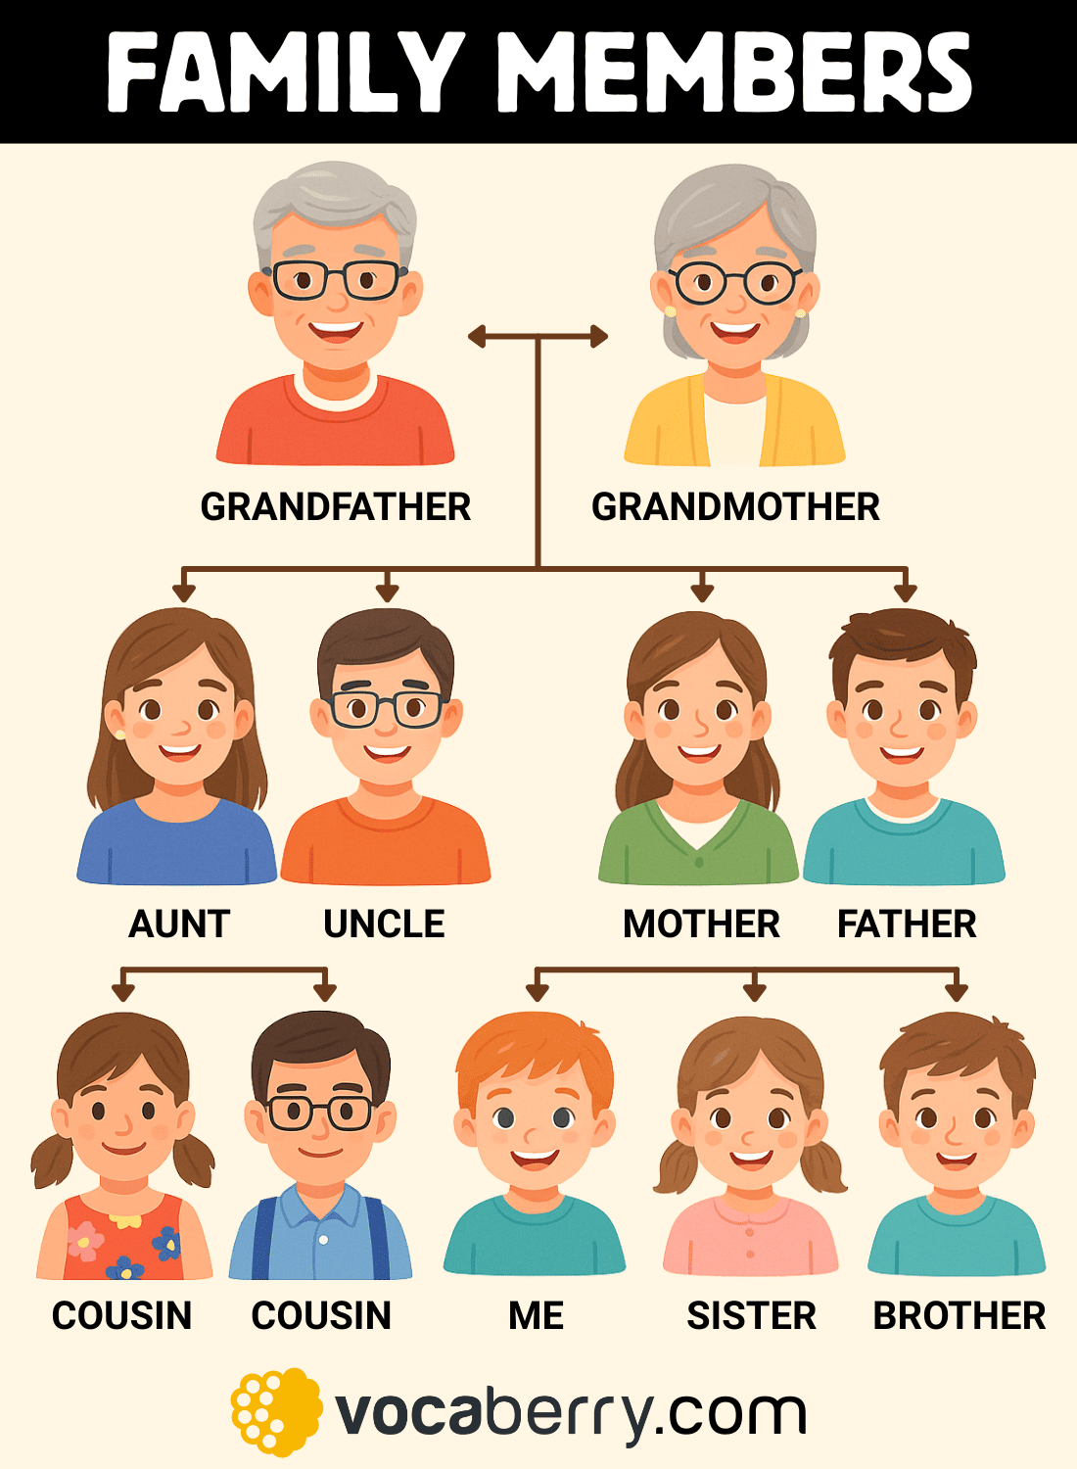

**3. Listening**

Уважно прослухай текст та виконай завдання на окремому аркуші.

**Monday, the nineteenth of May**

**Listening**

**TOM BRETT AND HIS FAMILY**

**I. Choose the right answer.**

1. Tom Brett is from …
   1. Great Britain;
   2. America;
   3. Africa.
2. He has got …
   1. a brother and a sister;
   2. a grandmother and a grandfather;
   3. an aunt and an uncle.
3. His mother is …
   1. a doctor;
   2. an engineer;
   3. a teacher.
4. Her name is …
   1. Nelly;
   2. Helen;
   3. Kate.
5. His father is …
   1. a pilot;
   2. an engineer;
   3. a driver.
6. His name is …
   1. Ben;
   2. Ted;
   3. Fred.
7. Jill and Fred are …
   1. engineers;
   2. doctors;
   3. drivers.
8. Jill and Fred have got …
   1. a daughter;
   2. a son;
   3. a son and a daughter.
9. Bill wants to be …
   1. a doctor;
   2. a driver;
   3. a pilot.
10. Kate wants to be...
    1. a teacher;
    2. an engineer;
    3. a doctor.
11. Tom has got …
    1. a dog;
    2. a kitten;
    3. a cat.
12. Spot likes to play with …
    1. cats;
    2. dogs;
    3. Tom.

**II. Write True or False.**

1. Tom Brett is from America.
2. He has got a mother, a father, a grandmother and a grandfather.
3. His mother is a doctor.
4. His father’s name is Ted.
5. Jill and Fred are teachers.
6. They have got a son and a daughter.
7. Tom wants to be a pilot.
8. Tom likes to play with Spot, but Spot doesn’t like to play with Tom.

**TOM BRETT AND HIS FAMILY**

Tom Brett is from America. He is eleven. He has got a mother and a father. He hasn’t got a grandmother and a grandfather, but he has got an aunt and an uncle.

His mother is a teacher. Her name is Helen. His father is a driver. His name is Ben.

His aunt and his uncle are engineers. Their names are Jill and Fred. They have got a son and a daughter. Bill is their son and Kate is their daughter.

Bill and Kate are pupils. Bill wants to be a driver. Kate wants to be a doctor.

Tom doesn’t want to be a doctor. He wants to be an engineer.

Tom has got a dog. His name is Spot. Tom likes to play with Spot and Spot likes to play with Tom, too.

Spot loves Tom and his family, but he doesn’t like cats. He doesn’t want to play with cats and cats don’t want to play with Spot.

**3. Homework**

**Домашнє завдання:**

* Повторити вивчений лексичний матеріал з теми «Family». Написати розповідь про свою родину (6-7 речень)

**Фотозвіт виконаної роботи надсилати на Human.**